ME218A Project Report Review
Prepared by: The Frankenstein Team
Prepared for: Team Firefox

General Comments:
The Flicker:
- We really liked your flicker
- Very elegant design. Nice and simple.
- We liked how all your circuitry can run off just 5V.
- The instructions state that the start button should be placed on the left hand side; yours is on the right:
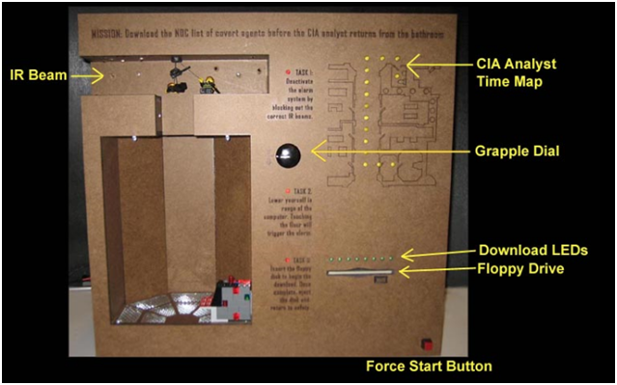
- The instructions state that "Any static instructions must be only in pictorial form", each of your tasks clearly have instructions in text:
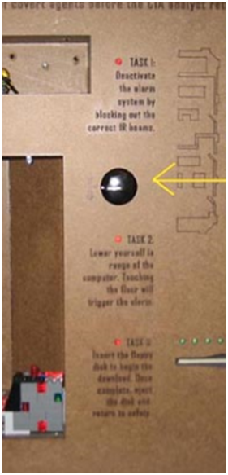

The Website Report:
- Images and the navigation panes shift from page to page. This is the case with both the top and left navigation panes.
- Table sizes are inconsistently defined between pages, and may display incorrectly on certain browsers. For example, the same table is defined as 1000px and 800px between “Description of Functionality” and “Project Requirements”:
- Misc. Formatting/Typos issues:
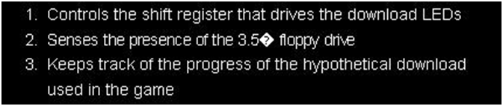
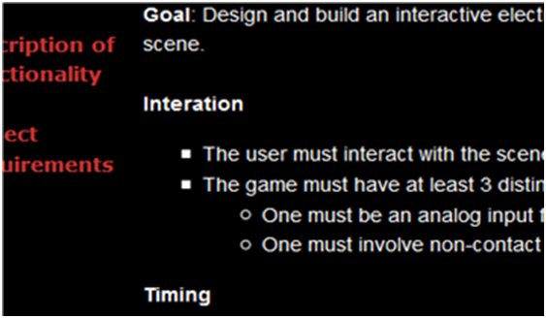

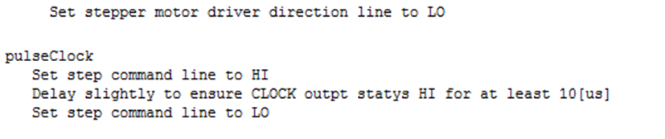
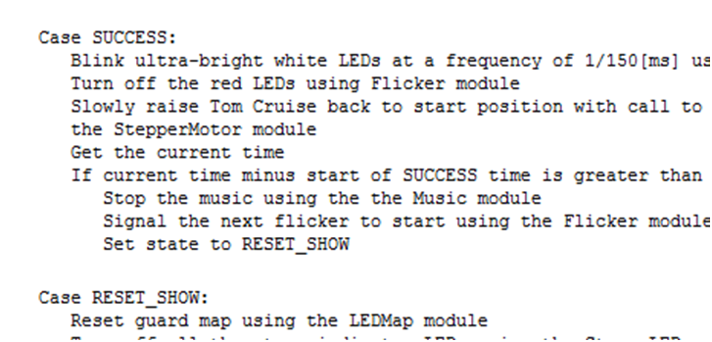
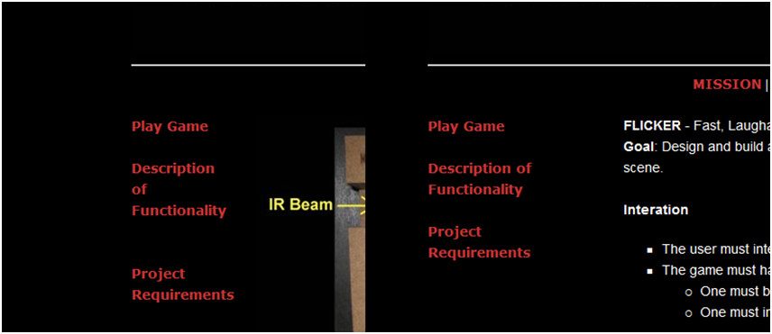
- The table color / table border sizes could be defined in the css style sheet instead of inline (neater code)
- Minor note: some computers may block the Javascript running in the image gallery

Section by Section Review:
Mission:
Mission – Play Game:
- Explanations make sense
- We would suggest making the image on the main page of your flicker larger. The size right now shows the overall flicker but with a larger image, the text on the flicker will be readable and the detail of the map will be clearer

Mission – Description of Functionality:
Diagram:
- Flicker start button should be on the left hand side, in the picture its on the right hand side.
- In the diagram the IR Beam is labeled, but it is hard to see exactly where the IR Beam is along that top shelf. Perhaps making a zoomed view of the top shelf would help to distinguish which of the LED’s are parts of the “IR Beam”.
Game Play:
- For Task 2 you should make it clear what and where the ‘computer’ is. Explain that the little grey Lego blocks at the bottom of the tunnel the Lego Tom Cruise propels down is the computer you are referring to. Also add that getting in range means lowering him right in front of the computer without hitting the floor.
Sensors:
- For Disk download, we would just write out fully what SPST is for the push button.
Actuators:
- Explain a bit more on what you mean by “the speed depends on how far the dial is turned”. Is that how far the dial was turned since the flicker started or each time the user turns the dial.

Hardware:
Circuit Designs:
- Nicely labeled board schematic, we really liked your "complete schematic" image
Flicker Receiver:
- Looks like it would work
- Parts list cites a 2N7000 MOSFET, though we couldn't find one in the circuit diagram
- Parts list cites a 9.1 ohm resistor; the circuit diagram says it's 9.1k
CIA Analyst Time map:
- Looks like it would work
- Parts list missing the LEDs
IR LED Phototransistor pair
- Looks like it would work
- Parts list is missing the 10k resistor (R6 in the schematic)
Stage indicator LEDs:
- Looks like it would work
- Parts list is missing the LEDs
- Unconnected pin in the circuit diagram
Grapple Dial
- Looks like it would work
Stepper Motor:
- Looks like it would work
Disk Switch:
- Looks like it would work
Download LEDs:
- Looks like it would work
- Parenthetically, it’s worth noting we didn’t need to use Schmitt triggers to clean up the signal for our shift register (but then again, we used a different shift register). Creative solution to the problem
- Parts list is missing the LEDs
MP3 Player circuit:
- Looks like it would work
- How is the MP3 player reset from game to game? Does the MP3 player need to be started in a specific state (i.e. on a specific track) for this to work properly?
White Situation LEDs / Red Situation LEDs:
- Looks like it would work

CAD:
- Good CAD drawing, very clear
- No units on the dimensions (nm? mm? inches? miles? parsecs? light-years?)

Bill of Materials:
- Even accounting for the “fair market value” of “donated” parts, still below $150. Well within budget.
- Some items do not have a quantity specified (i.e. stepper motor, heat sinks, dial)
- Cost column not filled in for some items (Masonite, Acrylic, stepper motor driver, decoders)
- Inconsistent capitalization ("Supplied" vs "supplied")
Software:
- Very neat table showing all code files with their header files, pseudo, codes, and descriptions
- Pseudo code is very detailed, also a lot of comments in c files and header files for other coders to read and understand;
- Very good to use enumeration to define a class of constants;
- Function "wait" is defined in both main.c and flicker.c
- Too many variables are defined in the main function. This is unnecessary and may potentially cause problems. Alternative is to build some separate function to check the variable state.
- It is recommended that all initializations are done in a separate function so nothing like "DDRM" would show up in main.c. This would not only make the code cleaner and easier to follow by another coder, but also would make it convenient when debugging, since each function
can be tested separately including overall initialization function.
- TMRS12_InitTimer(timernumber,endtime) is an alternative way to build a timer. In this way, you may track 8 different timers at the same time without adding extra variables.

